APCR-TCN: Adaptive Periodic Cycle Residual Temporal Convolutional Network for Short-Term Electricity Load Forecasting

Li Yi
State Grid Sichuan Economic Research Institute
Chengdu City, China
603837932@qq.com
Guobing Zeng
Earth Observatory of Singapore，Nanyang Technological University
Singapore, Singapore
guobing.zeng@ntu.edu.sg
Xin Huang
School of Electrical Engineering and Information ,Southwest Petroleum University
Chengdu City, China
0009-0003-7713-2570
Peng Tang
AVIC Chengdu Aircraft Design and
Research Institute
Chengdu City, China
lykxhtp@163.com

Abstract—Accurate short-term electricity consumption forecasting is critical for energy management and smart grid optimization. However, existing temporal convolutional network often fail to effectively capture the strong periodicity inherent in household power usage, such as weekly and yearly cycles. To address this limitation, we propose an Adaptive Periodic Cycle Residual Temporal Convolutional Network (APCR-TCN). The model integrates three key components: an FFT-based adaptive period discovery mechanism, a multi-period temporal convolution module, and a cycle residual learning strategy. These designs enable the model to explicitly capture both local temporal variations and long-range periodic dependencies in electricity consumption data. Extensive experiments on the UCI Household Power Consumption dataset demonstrate the proposed APCR-TCN consistently outperforms several competitive baselines, including ARMIA, XGBoost, TCN, in terms of MAE, MSE, RMSE and $R^{2}$. Furthermore, qualitative results show that APCR-TCN produces more stable and accurate predictions, particularly in periodic fluctuation regions. The results validate the effectiveness of incorporating explicit periodic inductive bias into temporal convolutional architectures for time series forecasting.
Keywords—Short-term load forecasting; Household electricity consumption; Temporal convolutional network; Periodic pattern modeling; Cycle residual connection

Introduction
The rapid development of smart grids, distributed energy resources, and intelligent energy management systems has significantly increase the demand for accurate short-term electricity consumption forecasting. Reliable load management, dynamic pricing, and the stable operation of modern power systems. At the household level, precise forecasting further facilitates personalized energy-saving strategies and improves the effectiveness of home energy management systems.
Household electricity consumption exhibits strong temporal regularities. In particular, daily routines, weekly behavioral patterns, and seasonal effects introduce multiple periodic structures into power usage data. For example, electricity demand at a specific hour is often highly correlated with the demand observed at the same hour on previous days or weeks. Effectively modeling such periodic dependencies is therefore crucial for achieving high forecasting accuracy.
Tradition forecasting approaches, including autoregressive integrated moving average (ARIMA), support vector regression (SVR), and random forest, have been widely applied to energy prediction tasks. However, these methods generally struggle to capture highly nonlinear temporal relationships and complex long-range dependencies inherent in modern electricity consumption data. Recent advances in deep learning have substantially improved forecasting performance. Recurrent neural networks (RNNs), long short-term memory networks (LSTMs), gated recurrent units (GRUs), and Transformer-based architectures have demonstrated remarkable capabilities in modeling temporal dynamics. Nevertheless, recurrent models often suffer from limited parallelism and gradient propagation issues, while Transformer model incur quadratic computational complexity with respect to sequence length.
Temporal Convolutional Networks (TCNs)[1] have emerged as an efficient alternative for time-series forecasting. By combining causal convolutions, residual connections, and dilated convolutions, TCNs can capture long-range dependences while maintaining parallel computation and stable optimization. Despite these advantages, conventional TCNs typically employ exponentially increasing dilation factors, such as 1, 2, 4 and 8, without considering the intrinsic periodic structure present in energy consumption data. Consequently, the learned receptive fields may not align with meaningful temporal cycles, such as 24-hour or 168-hour patterns, potentially limiting forecasting performance and interpretability.
Motivated by this observation, we propose an Adaptive Periodic Cycle Residual Temporal Convolutional Network (APCR-TCN) for household power consumption forecasting. The proposed method explicitly incorporates periodic inductive biases into the TCN architecture. First, an adaptive period discovery module based on Fast Fourier Transform (FFT) automatically identifies dominant temporal cycles from historical data. Second, a multi-period convolution mechanism performs parallel temporal convolutions using the discovered periods as dilation factors, enabling the model to simultaneously capture local and long-range periodic dependencies. Third, a cycle residual connection introduces information from previous daily and weekly cycles directly into the feature propagation process, improving both forecasting accuracy and model interpretability.
The main contributions of this work are summarized as follows:
- We proposed APCR-TCN, a novel temporal convolutional architecture that explicitly integrates adaptive periodic information into the forecasting process.
- We introduce a multi-period convolution module that aligns convolutional receptive fields with meaningful temporal cycles discovered from data rather than relying on predefined exponential dilation schedules.
- We design a cycle residual mechanism that incorporates historical observations from previous periodic intervals, enabling effective exploitation of daily and weekly consumption regularities.
- Extensive experiments on the UCI Household Power Consumption dataset demonstrate that the proposed approach achieves superior performance in terms of MAE, MSE and MAPE compared with conventional TCNs and other representative forecasting models.

Related work

Traditional Time Series Forecasting Methods
Early approaches for electricity consumption forecasting are primarily based on statistical models, such as Autoregressive Integrated Moving Average (ARIMA) and its variants. These methods assume linear temporal dependencies and stationary data distributions. While ARIMA-based models have been widely applied in short-term load forecasting tasks, their ability to model nonlinear and highly dynamic patterns in real-world electricity consumption data is limited. In particular, household-level power usage exhibits strong nonlinearities and external dependencies, which are difficult to capture using traditional statistical approaches.

Machine Learning-based Methods
Identify applicable funding agency here. If none, delete this text box.
To overcome the limitations of statistical models, machine learning approaches such as Support Vector Regression(SVR), Random Forest (RF) and Gradient Boosting Machines (GBM) have been introduced into energy forecasting tasks. These models improve predictive performance by learning nonlinear mappings from historical observations. However, their effectiveness heavily depends on manual feature engineering, and they often struggle to capture long-term temporal dependencies when applied to raw time-series data.

Deep Learning for Time Series Forecasting
Recent advances in deep learning have significantly improved the performance of time series forecasting models. Recurrent neural networks (RNNs), including Long Short-Term Memory (LSTM)[2] and Gated Rrecurrent Units (GRU), are widely used for sequential modeling. Although these models are capable of capturing temporal dependencies, they suffer from limited parallelization and difficulties in modeling very long sequences.
To address these issues, convolution-based architecture such as Temporal Convolutional Networks (TCNs)[1], DelayNet[3], WaveNet[4], TimesNet[5] have been proposed. TCNs utilize causal convolutions and dilated convolution operations to expand the receptive field while maintaining computational efficiency. Compared with recurrent models, TCNs offer better parallelism and more stable gradient propagation. However, the commonly used exponentially increasing dilation strategy (e.g., 1, 2, 4, 8...) does not explicitly consider the intrinsic periodicity present in electricity consumption data.

Periodicity-aware and Transformer-based Models
To better capture long-range dependencies, Transformer-based[6][7] architecture and their variants (e.g., Informer[8], Autoformer[9], and FEDformer[10]) have been applied to time series forecasting. These models rely on attention mechanisms to capture global dependencies but often suffer from high computational complexity and large data requirements.
Recently, periodicity-aware methods have attracted increasing attention. These approaches explicitly model seasonal and cyclic patterns in time series data, such as daily and weekly cycles in electricity consumption. However, most existing methods either rely on fixed periodic assumptions aor introduce additional computational overhead.
In contrast, our proposed APCR-TCN explicitly integrates adaptive periodic discovery and cycle-aware convolution into a lightweight TCN framework, enabling efficient and interpretable modeling of household electricity consumption patterns.

Methodology
In this section, we present the proposed Adaptive Periodic Cycle Residual Temporal Convolutional Network (APCR-TCN) for short-term household power consumption forecasting. The overall architecture is designed to explicitly incorporate periodic inductive biases into a convolutional forecasting framework.

Problem Definition
Let the historical household power consumption sequence be denoted as :
$X=x_{1},x_{2},...,x_{T}$ 
where $x_{t}∈R$ represents the electricity consumption at time step $t$, and $T$ is the length of the look-back window.
The objective of short-term forecasting is to learn a mapping function:
${\hat{y}}_{T+H}=f(X)$ 2
where $H$ denotes the forecasting horizon.

Overall architecture
The overall architecture of APCR-TCN is illustrated in Fig.1. The framework consists of three major components:
- Adaptive period discovery based on frequency-domain analysis;

Fig.1. The overall architecture of the proposed APCR-TCN

- Multi-period temporal convolution blocks for extracting features at different temporal scales;
- Cycle residual connections for preserving periodic dependencies across historical cycles.
The extracted representations are subsequently fed into a lightweight prediction head composed of fully connected layers to generate the final forecast.
Compared with conventional TCNs, the proposed framework incorporates domain-specific prior knowledge regarding periodic electricity usage patterns, enabling more effective modeling of daily and weekly consumption behaviors while maintaining computational efficiency.

Adaptive Multi-Period Temporal Convolution
Traditional TCNs employ exponentially increasing dilation factors 1, 2, 4, 8... , which enlarge receptive fields efficiently but do not necessarily align with intrinsic periodic structure of power consumption data. In residential electricity datasets, dominant cycles typically occur at daily, weekly and yerly intervals. Therefore, manually designed exponential dilation may overlook meaningful temporal dependencies.
To address this limitation, APCR-TCN introduces an adaptive period mechanism based on the Fast Fourier Transform(FFT). Given a historical sequence $X$, its frequency spectrum is computed as
$F(k)=\sum_{n=0}^{N−1}{x_{n}}e^{−j2πkn/N}$ 3
where $N$ denotes the sequence length. The dominant frequencies are identified according to their spectral magnitudes, and the corresponding periods are estimated as
$P_{i}=\frac{N}{k_{i}}$ 4
where $k_{i}$ represents the index of the $i$-th dominant frequency component.
The discovered periods are subsequently employed as dilation factors in multiple parallel convolution branches. Let
$P=1,P_{1},P_{2},…,P_{K}$ 5
denote the set of extracted periods. For each period $p_{i}$, a causal dilated convolution is applied:
$H_{i}=ϕ({Conv}_{d=P_{i}}(X))$ 6
where $ϕ(⋅)$ denotes the nonlinear activation function.
The output from all branches are concatenated and fused through a $1×1$ convolution:
$H_{f}={Conv}_{1×1}\left(Concat(H_{1},H_{2},…,H_{K})\right)$ 7
This design enables the model to simultaneously capture short-term fluctuations, daily patterns, and weekly seasonal behaviors within a unified framework.

Cycle Residual Learning and Prediction
Although multi-period convolutions provide diverse temporal representations, important periodic information may still be weakened during deep feature transformations. To preserve explicit cycle dependencies, APCR-TCN introduces a cycle residual learning mechanism.
For a given timestamp $t$, the output representation is formulated as
$Y_{t}=F(X_{t})+αX_{t}+βX_{t−P_{1}}+γX_{t−P_{2}}$ 8
where $F(X_{t})$ denotes the features produced by the multi-period convolution block, $p_{1}$ and $p_{2}$ correspond to the dominant daily and weekly periods, and $α$, $β$, $γ$ are learnable parameters.
This formulation allows the network to directly reuse information from previous cycles while adaptively determining the importance of current observations and historical periodic states. Consequently, the model can better distinguish regular consumption patterns from transient fluctuations.
Finally, the enhanced representations are passed through a lightweight prediction head consisting of two fully connected layers with ReLU activation. The overall design preserves the computational advantages of TCNs while incorporating explicit periodic inductive biases, making APCR-TCN particularly suitable for household electricity consumption forecasting tasks.

Experiments
This section evaluates the effectiveness of the proposed APCR-TCN model on UCI Household Power Consumption forecasting tasks. All experiments are conducted based on the implemented PyTorch framework, including training dynamics visualization, quantitative evaluation metrics, and qualitative prediction analysis.

Dataset and Experimental Settings
The UCI Household Power Consumption dataset is used to evaluate all models. The dataset contains minute-level electricity consumption records collected from a single household between 2007 and 2010. The dataset records electricity consumption variables at one-minute intervals, including global active power, global reactive power, voltage, and sub-metering information. In this study, we focus on the Global Active Power series for univariate forecasting.
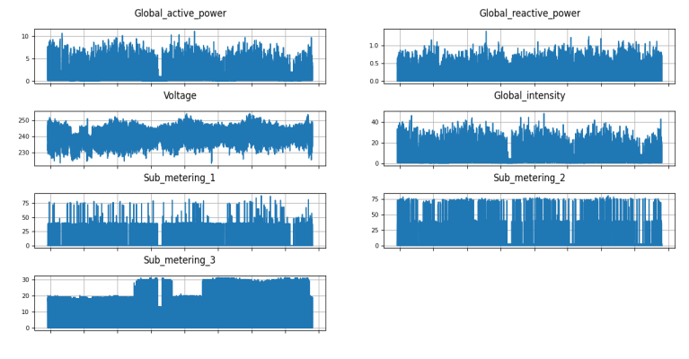Fig.2. The evolution of all seven features over time
Missing values represented by “?” were first converted into NaN values and subsequently filled using forward interpolation. To better understand the temporal characteristics of the dataset, we first visualize the evolution of all seven features over time. The resulting trend plots show that the variables exhibit clear non-stationary behavior, with noticeable fluctuations, abrupt changes, and recurring periodic patterns. In particular, the power-related variables display strong temporal dependence, indicating that the forecasting model should be able to capture both short-term variations and long-range seasonal dynamics.
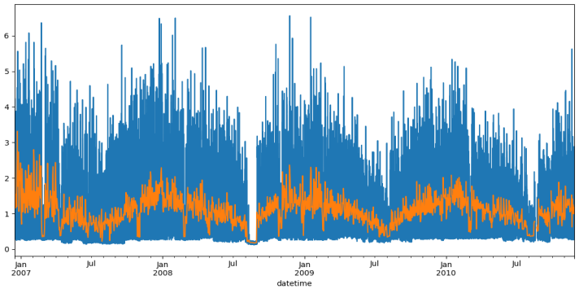
Fig.3. The evolution of hourly-sampled and daily-sampled Global Active Power series
To further investigate the periodicity of the target variable, we perform seasonal decomposition on the daily-sampled Global Active Power series. The decomposition separates the signal into trend, seasonal and residual components. The trend component captures the overall long-term evolution of electricity usage, the seasonal component reveals recurring periodic patterns, the residual component reflects irregular fluctuations and noise. The decomposition results demonstrate that the series contains strong seasonal regularities, which motivates the use of periodic modeling mechanisms in the proposed APCR-TCN framework.
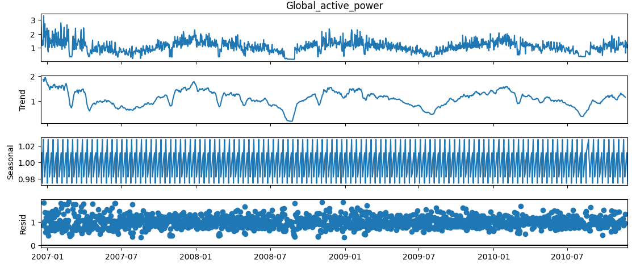
Fig.4. The decomposition of daily-sampled Global active power
The dataset was divided into training and testing sets with proportions of 75% and 25%, respectively.
All models, including ARIMA, XGBoost, TCN and APCR-TCN, are implemented and evaluated under identical settings to ensure a fair comparison. The training configuration is as follows:
- Optimizer: Adam
- Learning rate: 1e-3
- Batch size: 32
- Training epoch: 100
- Hardware: NVIDIA GPU

Forecasting Evaluation
For forecasting evaluation, we adopt three widely used metrics: Mean Absolute Error (MAE), Mean Square Error (RMSE), Root Mean Square Error (RMSE), and Coefficient of Determination ($R^{2}$), their definitions are given below:
$MAE=\frac{1}{N}\sum_{i=1}^{N}{\left|y_{i}−{\hat{y}}_{i}\right|}$ 9
$MSE=\frac{1}{N}\sum_{i=1}^{N}{{\left(y_{i}−{\hat{y}}_{i}\right)}^{2}}$ 0
$RMSE=\sqrt{\frac{1}{N}\sum_{i=1}^{N}{{\left(y_{i}−{\hat{y}}_{i}\right)}^{2}}}$ 1
$R^{2}=1−\frac{\sum_{i=1}^{N}{{\left(y_{i}−{\hat{y}}_{i}\right)}^{2}}}{\sum_{i=1}^{N}{{\left(y_{i}−\bar{y}\right)}^{2}}}$ 2
where $N$ denotes the number of test samples, $y_{i}$ is the ground truth value, $\hat{y}$ is the predicted value, and $\overline{y}$ is the mean of the ground-truth values. MAE measures the average absolute between predictions and observations, MSE penalizes larger errors more strongly, RMSE is the square root of MSE and retains the same unit as the target variable, and $R^{2}$ measures how well the predictions explain the variance in the observed data. For MAE, MSE and RMSE, smaller values indicate better forecasting performance, whereas a larger $R^{2}$ indicates better predictive accuracy.
TABLE I. Comparison of evaluation metrics
Evaluation Metrics | ARIMA | XGBoost | TCN | APCR-TCN
MAE | 0.4338 | 0.2088 | 0.2222 | 0.1854
MSE | 0.2665 | 0.0754 | 0.0886 | 0.0647
RMSE | 0.5162 | 0.2746 | 0.2976 | 0.2543
$$R^{2}$$ | -1.2478 | 0.3641 | 0.2592 | 0.4591
The experimental results show that APCR-TCN consistently achieves lower MAE, MSE, RMSE than the baseline models, including ARIMA, XGBoost and TCN, this improvement can be attributed to the proposed multi-period convolution, which captures temporal dependencies at different scales, and the cycle residual mechanism, which preserves explicit historical periodic information. These components enable APCR-TCN to better model the daily, weekly and yearly regularities in household electricity consumption, leading to more accurate and stable forecasts.
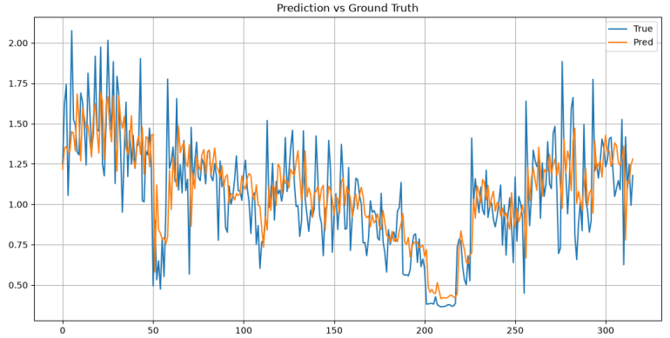Fig. 5.The comparison between prediction curve and ground truth.

Qualitative Analysis of Prediction Results
To further validate the effectiveness of the proposed method, we visualize the predicted results of APCR-TCN and ground truth values, as shown in Fig.5.
From the comparison, it can be observed that APCR-TCN closely follows the ground truth curve across most time intervals. The model is able to capture both the overall trend and local fluctuations of electricity consumption, indicating that the proposed periodic modeling mechanism are effective in learning the temporal dynamics of the series.
In particular, APCR-TCN shows strong alignment with the actual consumption pattern during periods of rapid change, demonstrating its ability to preserve important temporal variations while maintaining stable predictions.

Conclusion
In this work, we proposed APCR-TCN, a novel periodic-aware temporal convolutional network for household electricity consumption forecasting. The model enhances standard TCNs by incorporating adaptive period discovery, multi-period convolution, a cycle residual connections, enabling it to better capture intrinsic daily and weekly patterns in power usage data. Unlike conventional architectures that rely solely on exponentially increasingly dilations, APCR-TCN explicitly models periodic dependencies in both feature extraction and residual learning stages. Experimental results on the UCI Household Power Consumption dataset show that the proposed method consistently outperforms strong baselines in both quantitative metrics and qualitative forecasting performance. Overall, APCR-TCN demonstrates that integrating explicit periodic inductive bias into convolutional architectures is a simple yet powerful approach for improving time series forecasting performance.

References
- Bai, S., Kolter, J. Z., & Koltun, V. An Empirical Evaluation of Generic Convolutional and Recurrent Networks for Sequence Modeling arXiv:1803.01271, 2018.
- Staudemeyer R C, Morris E R. Understanding LSTM--a tutorial into long short-term memory recurrent neural networks[J]. arXiv preprint arXiv:1909.09586, 2019.
- Kim, T.; et al. (2023). "DelayNet: Enhancing Temporal Feature Extraction for Electronic Consumption Forecasting with Delayed Dilated Convolution". Energies, 16(22), 7662.
- Oord, A. v. d., et al. WaveNet: A Generative Model for Raw Audio arXiv:1609.03499, 2016.
- Wu, H., et al. TimesNet: Temporal 2D-Variation Modeling for General Time Series Analysis ICLR, 2023.
- Vaswani, A., et al. Attention Is All You Need NeurIPS, 2017.
- Liu, S., et al. Non-stationary Transformers: Exploring the Stationarity in Time Series Forecasting NeurIPS, 2022.
- Zhou, H., et al. Informer: Beyond Efficient Transformer for Long Sequence Time-Series Forecasting AAAI, 2021.
- Wu, H., et al. Autoformer: Decomposition Transformers with Auto-Correlation for Long-Term Series Forecasting NeurIPS, 2021.
- Zhou T, Ma Z, Wen Q, et al. Fedformer: Frequency enhanced decomposed transformer for long-term series forecasting[C]//International conference on machine learning. PMLR, 2022: 27268-27286.

